Date: September 16, 2019
Contacts: Angela Cato, Marketing Manager, Envision, Inc.
Office (316) 440-1518; Cell (316) 641-6844
Email: Angela.Cato@envisionus.com
Web: www.envisionus.com

Greg Pitkoff, Managing Director, GRiP Communications LLC
Office (718) 404-9277; Cell (718) 614-6677
Email: greg@gripcommpr.com

ENVISION PROGRAMS PARTICIPANT ANDREW MCLEOD RECEIVES $10K SCHOLARSHIP FROM HIGH TOUCH TECHNOLOGIES TO ATTEND WICHITA STATE UNIVERSITY

Wichita, Kan. – Envision announced today that Andrew McLeod has been awarded the High Touch Computer Information Systems Scholarship for the Blind or Visually Impaired at Wichita State University (WSU). McLeod is a freshman at WSU majoring in computer science.

Funded by High Touch Technologies, a Wichita-based software, technology and communications company, the $10,000 scholarship provides tuition support for one full academic year or two semesters to a WSU student with vision loss who plans to major in computer information systems, computer science, information technology or a related technology field.

McLeod, whose visual impairment is due to Leber’s congenital amaurosis, has taken part in almost every youth program offered at Envision since he was 3 years old. His participation in Envision’s national Level Up middle school and high school programs that prepare students with vision loss for higher education and employment led to his connection with High Touch and an interest in technology. McLeod secured an internship with High Touch in December 2016 and will again participate in the internship program in 2019.

“We are extremely proud of Andrew for his ongoing accomplishments. He is the epitome of Envision’s mission and a positive example of how individuals who are blind or low vision are dispelling stereotypes and thriving in advanced, high-tech fields,” said Heather Hogan, senior vice president, Foundation & Mission Services at Envision. “We are grateful for High Touch’s partnership in helping us open doors to greater independence, career advancement and quality of life for Andrew and others with visual impairments.”

High Touch has an extensive history with Envision. In addition to the Level Up program, High Touch is a sponsor of the annual Evening with Envision gala and an advocate for Envision’s mission throughout the community.
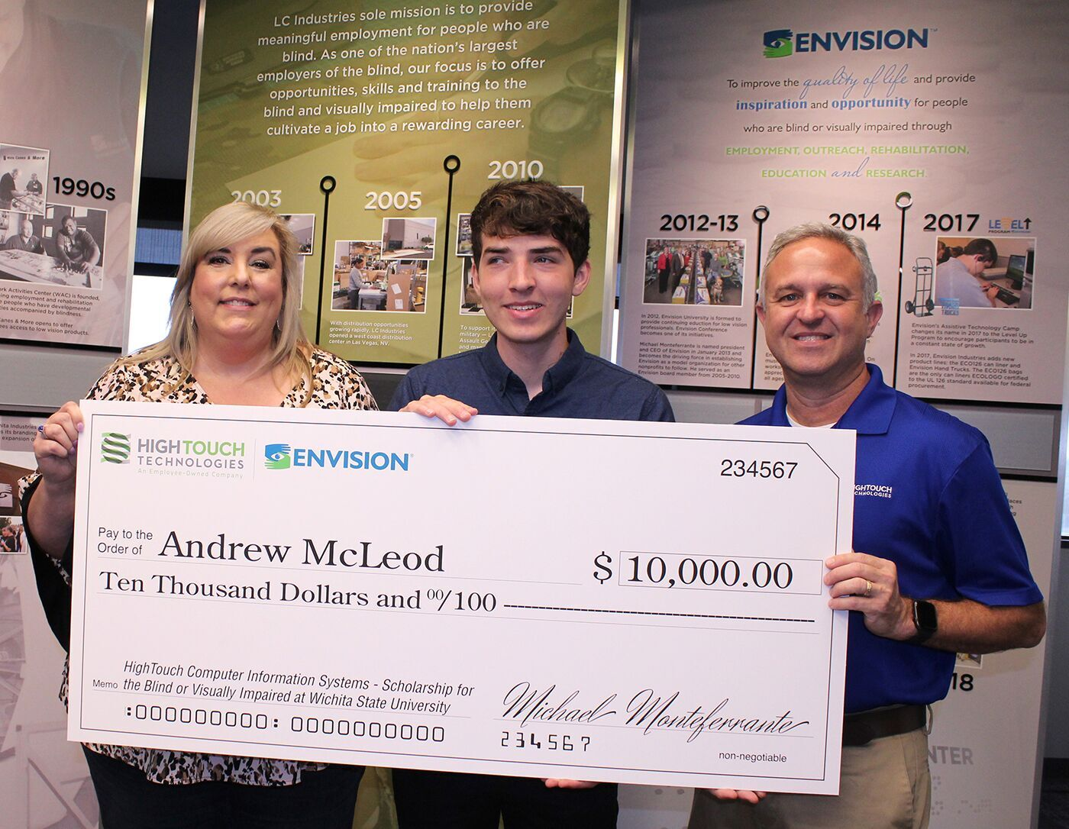
Andrew McLeod (center), with Heather Hogan, senior vice president, Foundation & Mission Services at Envision, and Kevin Colborn, senior vice president of technology solutions at High Touch Technologies. McLeod received the 2019 High Touch Computer Information Systems Scholarship for the Blind or Visually Impaired at Wichita State University (WSU). McLeod’s participation in Envision’s national Level Up middle school and high school programs, which prepare students with vision loss for higher education and employment, led to his connection with High Touch and interest in technology.

“Our relationship with Envision has provided many exciting opportunities to nurture the talents of people with vision loss who have great potential,” said Kevin Colborn, senior vice president of technology solutions at High Touch. “Through this scholarship, we will cultivate the next generation of experts who are blind or have low vision whose technological abilities will benefit our company and, quite likely, the world at large. We are delighted to present Andrew McLeod with this year’s scholarship, honoring the contributions he already has made and investing in those we’re sure he’ll make in the future.”

About Envision: Envision promotes advocacy and independence for those who are blind or low vision. Founded in 1933, Envision is one of the largest employers of individuals with vision loss in the nation. Headquartered in Wichita, Kan., Envision’s mission is to improve the quality of life and provide inspiration and opportunity for people who are blind or visually impaired through employment, outreach, rehabilitation, education and research. For more information, visit www.envisionus.com.

About High Touch Technologies: High Touch delivers client-tailored software, technology and business communication solutions that solve unique challenges in any industry. With key strengths in rent-to-own, healthcare, manufacturing, non-profit, professional services and utilities, High Touch helps businesses grow by expanding their technology and communications capabilities. High Touch brings the human touch to technology, serving business clients with IT solutions, software solutions, security solutions, business communications and website services. Based in Wichita, Kan., High Touch has offices in Dallas, Denver, Kansas City, Corpus Christi and San Antonio. For additional information on High Touch Technologies, visit www.hightouchtechnologies.com.

